**CREATE A SOCIAL MEDIA POST**

*Project report template:*

**INTRODUCTION**

1.1 Over view:

A content plan should consist of the se of multiple types of content, including videos, blogs, ebooks, videos, and content developed just for stories. Depending on the types of social media platforms you use, you should also plan your captions or post copy.

1.2 Purpose:

The main purpose of social media posts is to increase brand awareness and visibility. The more people know about your social media presence, the more people you can potentially turn into customers. Social media posts also helps in building relationships with your audience when they engage with your posts.

* Adapt your comment to the number of characters allowed on each platform. Take a look at the number of characters displayed in the preview to make your meaning come through.
* Make sure your images correspond to the [images sizes the networks provide](https://makeawebsitehub.com/social-media-image-sizes-cheat-sheet/). Consider adapting your images to create specific images for Pinterest and Instagram to make sure your message will be presented in the best way to fit these platforms.
* Share your posts to your social media profiles and pages with different comments for your message that will hit the language use of the respective community and focusses on their topics and interests.
* Share your posts on different days and at different times of the days. Networks and communities have specific rush hours for traffic and engagement.

**2. PROBLEM DEFINITION & DESIGNIN THINKING:**

**2.1 EMPATHY MAP:**

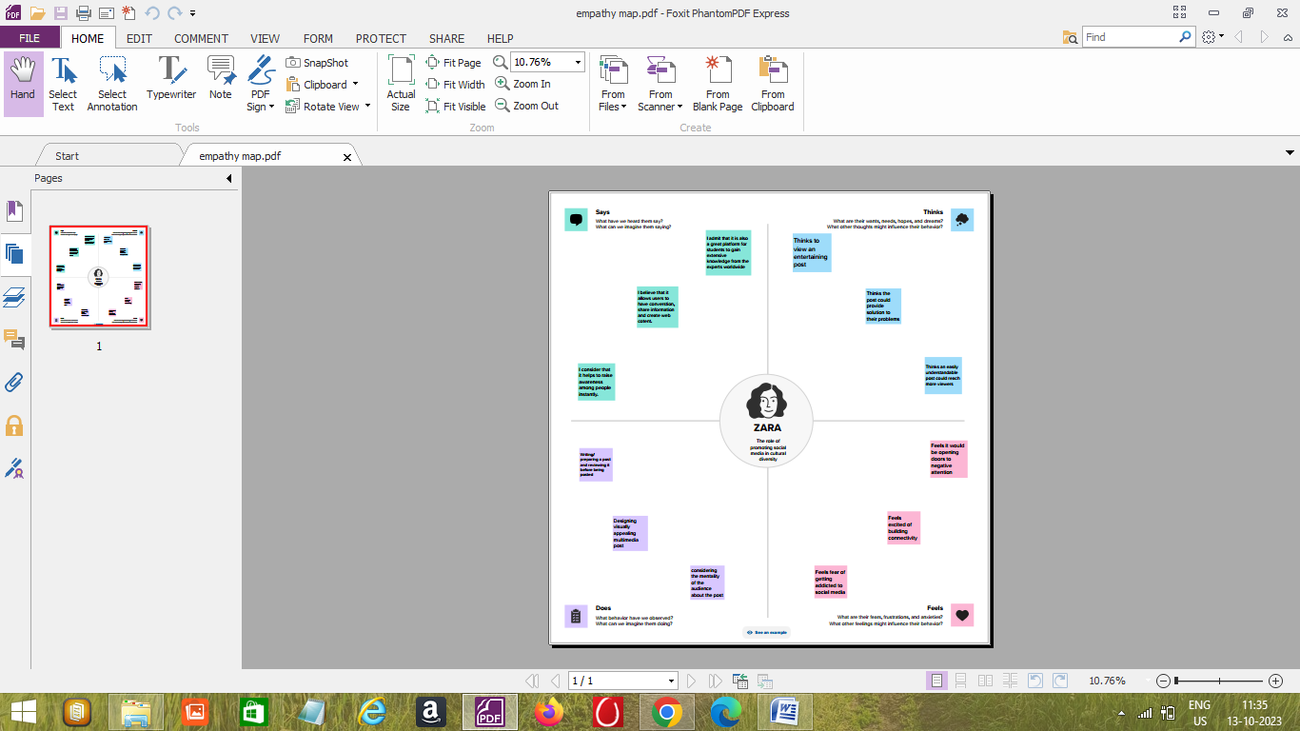

**2.2 IDEATION & BRAINSTORMING:**

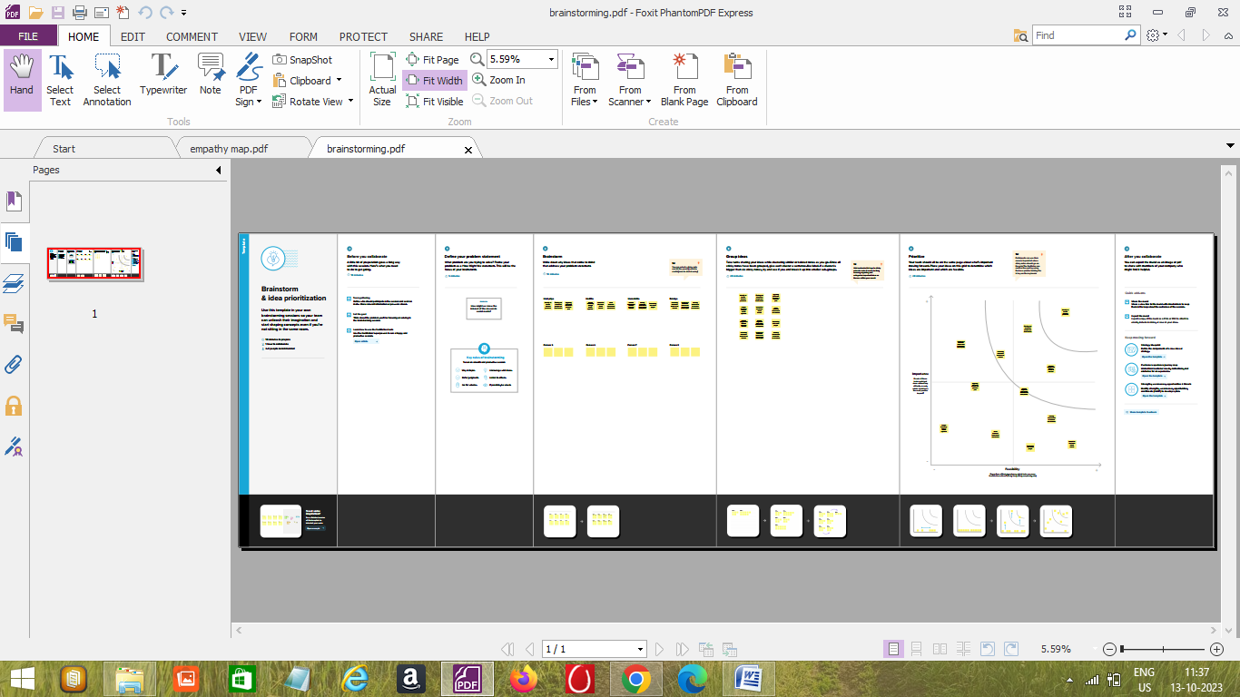

**3. RESULT:**

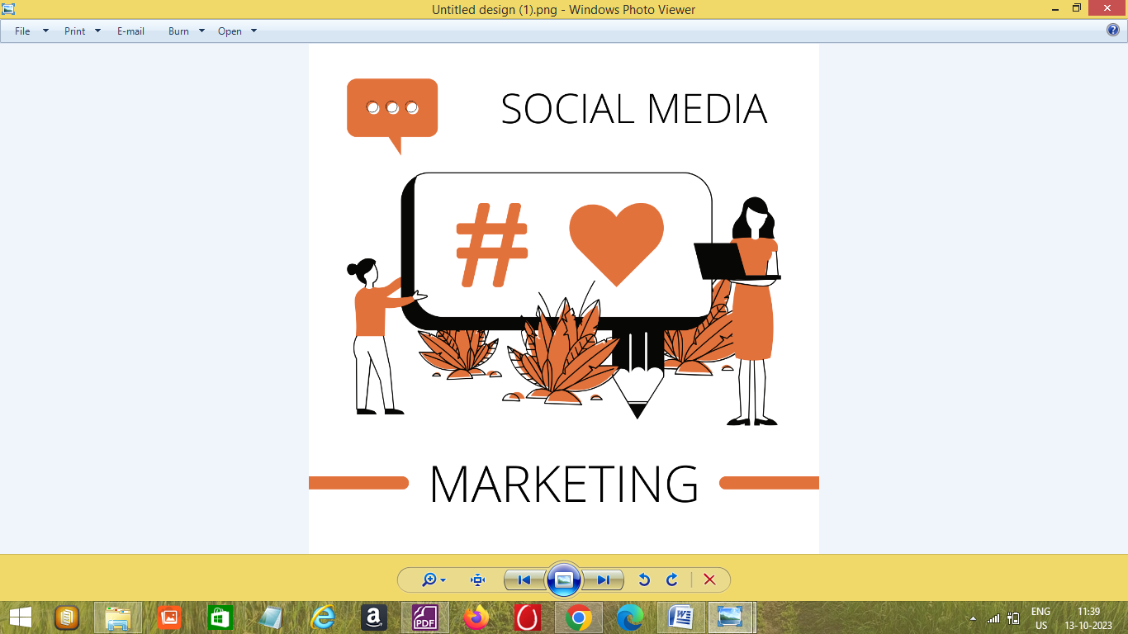

**4. ADVANTAGES AND DISADVANTAGES:**

* One of the most important advantages of social media is connectivity. It can connect innumerable people from any place at any time.
* Social media has proved beneficial in the field of education. It makes learning easier by connecting educators and experts worldwide with learners
* Social media lets you keep yourself updated about any happenings in the world or someone’s life.
* Social media marketing has helped increase business rapport by building goodwill amongst people, and its promotion leads to increased sales, thereby increasing profits.
* Social media helps in improving customer interaction after delivering products and services and getting feedback on the same.

**5. APPLICATION:**

People use social media to stay in touch and interact with friends, family and various communities. Businesses use social applications to market and promote their products and track customer concerns. Business-to-consumer websites include social components, such as comment fields for users.

**6. CONCLUSION:**

Through this project we learnt to create any type of social media post using canva. This project is useful to us to give a good performance in creating a social media post.